POL
STUDENT LESSON PLANS
CRITERIA & CHECKLIST

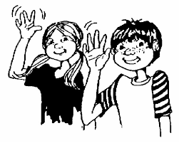
Introduction
- Introduce yourselves, the POL program and your topic
- Ask students what they know about your topic
For example:
“Hi, I’m _______ and I am in the Aboriginal Principles of Learning class. Our class is a bit different from a regular class because we learning by exploring our plants, environment and the community. We are also learning about T’Sou-ke Nation, Aboriginal knowledge and sustainable practices and Aboriginal Principles of Learning. We like to start by acknowledging the territory we are on (read the proper territory acknowledgment). We are happy to be able to come and teach you about the things we are learning. Does anyone have any questions about how what we do in our classroom?”
(Answer questions the best way you can. If you don’t know the answer, let the students know you will try to find the answer)
“Today we are going to teach you about ___________________. What do you know about__________________?”
(Take about 4 comments; keep students on track if they get off of the topic)
What would you like to know about __________________?
(Take about 4 questions; keep students on track if they get off of the topic)
“Ok, let’s start the presentation! Please pay close attention because we are going to do an activity afterwards where you can show what you have learned.”
-OR-
“We are here to teach you about solar energy!! Does anyone know what solar energy is or where it comes from? Does anyone know how sunlight is turned into power? We are going to learn a lot more about that and how the T’Sou-ke first nation is using solar power to create enough power to sell back to BC Hydro.
Here are the things we are going to talk about today.
- Our trip to T’Sou-ke Nation to see the solar plant.
- The two types of solar panels
- How sun energy is turned into electricity.
- Activity: Ways you can save energy at home!”

WRITE DOWN YOUR INTRODUCTION PLEASE

Presentation
Now is the time that you will be presenting the information you want to share. Some options for presenting your lesson are:
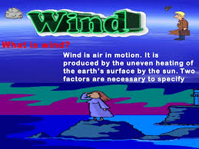

- PowerPoint Slide Show
- Poster Board
- Play or Skit
- Hands On Activity or Demonstration
- Learning walk (provide pictures of plants to look for)

All information for your presentation must be in your own words. Information can be gathered from your field guides, your experiences and knowledge, books, and CREDIBLE Websites, interviews with your family, friends, and teachers. It is also important to have some interesting visuals like photographs, pictures, drawings, models or artifacts and samples. Please put effort and care into your presentations.

Your Presentation Must Include:

- A list of learning goals in point form (what you expect the students to learn)
- At least 3 subtopics related to your topic
For example:
My topic is CEDAR TREES
My subtopics are Habitats & Identification, Uses, and Aboriginal Legends & Stories
- 5 to 10 facts in each subtopic
- Notes of all the things you want to talk about so that your presentation can be point form with images, pictures and drawings.
- Real life samples related to your topic for students to look at or touch.
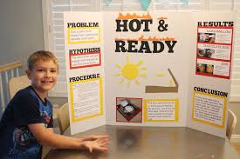
- Student involvement and audience participation when possible (student volunteers to demo ideas. Think of the astronomy presentation)

Learning Activity
The goal of the closing activity is for students to show what they have learned from you. Examples of closing activities include:
- Games like: sorting games (Can You Flush It?), Matching games (Mineral and Product), bingo, trivia, jeopardy)
- Question sheets
- Group art activity with clear expectations
- Short experiment
- Role playing (group short skits to show the uses of cedar)
- Three W’s sheet (What I learned, What I liked, What I want to know)
There are lots of great ideas for learning activities on the internet if you type “ways to showing learning” into google. If your presentation is long, choose a short learning activity, but it must be an activity that shows what the students have learned.
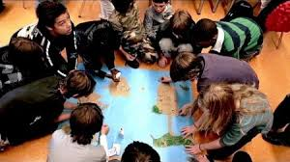

WRITE DOWN CLEAR INSTRUCTIONS FOR YOUR LEARNING ACTIVITY PLEASE

CLOSING

Thank the students for having you in their class and for being great learners. Ask if anyone has a question (only take two or three). Collect any materials from the student and from your presentation. Say good-bye, Phew! You’re done! Great Job!!!!

*If you need help getting photographs, photocopies, samples or examples, or materials, please write a list and submit it to Ms. Stuart or Ms. Wood as soon as possible.
Name:____________________________________________________

Checklist

⃝ I have written an introduction and had it checked by a teacher.

⃝ I have created a presentation that follows the criteria and has been checked by a
teacher.

⃝ I have written speaking notes for my presentation and had them checked by a
teacher.

⃝ I have a learning activity that follows the criteria and has been checked by a teacher.

⃝ I have a materials list for my lesson that has been checked by a teacher.

⃝ I have all my materials ready and organized.

⃝ I have practiced my lesson.

⃝ I have presented my lesson to our class.

⃝ I have presented my lesson to another class.

My Reflection

What went well: ____________________________________________________________________________________________________________________________________________________________________________________________________________________________________________________________________

What I would change or add: _____________________________________________________________________________________________________________________________________________________________________________________________________________________________________________________________________________________________________________________________________

What I learned from this experience: ____________________________________________________________________________________________________________________________________________________________________________________________________________________________________________________________________

My thoughts and feelings: ____________________________________________________________________________________________________________________________________________________________________________________________________________________________________________________________________

Tips and advice I would give to another student who wants to teach a lesson: ___________________________________________________________________________________________________________________________________________________________________________________________________

